***Project Document***

***of***

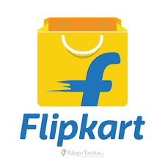

***By,***

**Bharati Bedare M.Sc(CS)**

**Edureka Intern 2022**

**Type: Private**

**Industry: E-Commerce**

**Website:** [**https://www.flipkart.com**](https://www.flipkart.com)

**Area Served: India**

**Products : Grocery , Beauty, Home, Fasion products, Toys , Electronics, Appliences etc**

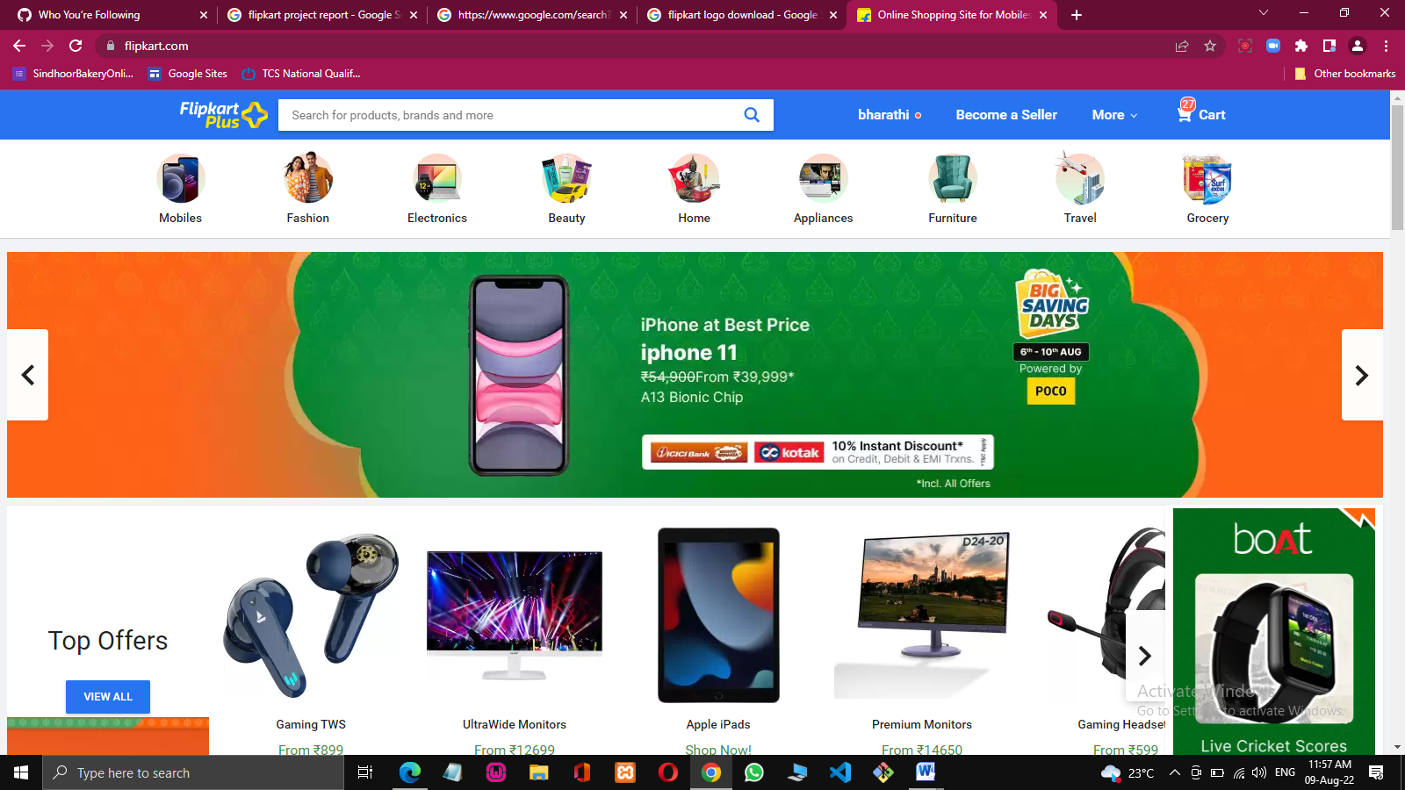

**Home Page:**

It includes,

**Header section**: It contains Flipkart logo, search bar, account details, selling options & cart.

**Account details:** It is included in the header section, It contains account holder details, orders placed by the account holder, Wishlist of the account holder, logout , notifications & coupons.

**Login/Sign in section:** It allows the user to log in or sign in to the website.

**Offer Section:** It contains the offers available at the website according to the current ongoing seasons/trends.

**Categories:** It allows the user to browse the products according to the categories and sub-categories.

-Fashion

-Electronics

-Beauty

-Home

-Appliances

-Furniture

-Grocery

**Top Offers:**

Offer on Products, stock clearance sale, end of season sale, Etc.

**Footer:**

Footer includes, Contact us, Help, policy, social, Mail Us, Registered Office Address & copy right section.

**List Page:**

It includes,

- Great deals on particular product category.

- Brief information about the product.

- Options to add to cart or buy the product.

**Product over Page:**

It incudes,

* Brand, Price, Sizes available, offers available, product images.
* Options like Buy Now & Add to cart.
* Delivery Date, shipping charges or Free Delivery.
* Ratings of that products.
* Option to wishlist the product.

**Payment Page:** It allows the user to make payment through online or pay at the time of delivery.

**Order Conformation:** Order is confirmed after choosing one of the payment option.